User Documentation for the
State and National
Area Health Resources Files (AHRF)
2014-2015 Release

U.S. Department of Health and Human Services
Health Resources and Services Administration
Bureau of Health Workforce
National Center for Health Workforce Analysis
June 2015



AHRF USER DOCUMENTATION

CONTENTS

Introduction 1
American Community Survey (ACS) 2
Bureau of Labor Statistics (BLS) 4
Integrated Postsecondary Education Data System (IPEDS) 6

Introduction

The Area Health Resources Files (AHRF) State and National data files contain data from three sources: the 2011-2013 American Community Survey from the U.S. Census Bureau, the May 2014 Occupational Employment Statistics file from the Bureau of Labor Statistics and the 2012-2013 Integrated Postsecondary Education Data System (IPEDS) file from the National Center for Education Statistics, U.S. Department of Education.

Both the American Community Survey (ACS) and the Bureau of Labor Statistics (BLS) provide information on the number of practitioners in each jurisdiction, and these sources arrive at the counts using different approaches, and therefore, provide slightly different values. The ACS surveys a representative number of people in each state and based on the responses, estimates the number of health sector personnel in each of the Standard Occupational Codes, or SOC. The BLS surveys employers and asks the number of jobs that are filled by SOC.

The ACS PUMS provides a broad range of demographic information regarding the make-up of the workforce – this level of detail is not available in BLS data. The BLS data provides counts of jobs filled, and provides wage information not available in ACS. Therefore, these sources look at the labor force from different perspectives and yield differences. The National Center for Health Workforce Analysis (NCHWA) provides both sets of data for use based upon the user’s particular interest.

American Community Survey (ACS)

American Community Survey Public Use Microdata Sample (ACS) data were downloaded from the U.S. Census Bureau. The 2011-2013 ACS data file is approximately a 3 percent sample of the U.S. population by combining the 1 percent samples in the 2011, 2012, and 2013 ACS. The ACS data are collected throughout each calendar year and represent the aggregate characteristics over a 3-year period. There are over 9 million records in the 3-year 2011-2013 ACS data file.

The 3-year ACS file was used, rather than the most recent single-year ACS file, in order to have sufficient sample sizes. Although the 3-year ACS has over 9 million records, the health professions included on the AHRF encompass approximately 555,000 records. While many of the health care professions included on the AHRF have substantial sample sizes, a number of professions have relatively small sample sizes. Sample size is particularly important when reporting on the demographics of the professions and when reporting on the workforce by state.

The health professions included on the AHRF were selected based on the following criteria: (1) the profession is among the top 50 having the largest number of jobs in the health sector as identified by the BLS Standard Occupation Classification (SOC) code for the profession and/or (2) the profession is among the fastest growing health professions as forecast by BLS. These determinations were made based on data from the BLS 2014 Occupational Employment Statistics files.

The race/ethnicity categories reported are White (Non-Hispanic), Black/African American (Non-Hispanic), Hispanic, Asian/Native Hawaiian/Pacific Islander (Non-Hispanic), American Indian/Alaska Native (Non-Hispanic), and Multiple/Other Race (Non-Hispanic).

Age groups reported are: less than 35 years old, 35-55 years old, and more than 55 years old.

Workforce settings are reported for each profession, as applicable. The number of settings reported varies by profession.

Data are suppressed for any value where the percent relative standard error (PRSE) is greater than 30%. In addition, work settings for a given profession for which there were fewer than 10 states reported and for which the national total for that setting in that profession represented less than 3% of the total for that profession are not included on the file. If a setting-profession combination had 10 or more states reported or if it had 9 or fewer states but the national total represented 3% or more of the national total for the profession across all settings, the setting data are reported.

For each profession, the workforce is defined as individuals employed in the profession, and those individuals whose last job was in the profession and who are still in the workforce seeking employment (e.g., individuals unemployed because they were laid off). The definition of workforce was used to include individuals who may have been affected by the recession that began in 2008. The 2011-2013 ACS file included a variable that distinguishes between nonworking individuals in the workforce from those no longer in the workforce. State workforce estimates are based on the reported location for place of work; when place of work is not reported, state of residence is used.

The U.S. population estimates of the age groups, the race/ethnicity and the sex distributions were derived from 2011-2013 ACS for the population 16 years of age or older to represent the working age population. The population estimates from the 2011-2013 ACS, in particular, represent fundamentally the average annual population distributions for the 3-year period 2011 through 2013—a property consistent with the estimates for each profession based upon the 2011-2013 ACS.

The following professions are included on the AHRF as analyzed from the 2011-2013 ACS PUMS. The associated SOC codes and Classification of Instructional Program (CIP) codes included for associated training data are also included in the table.

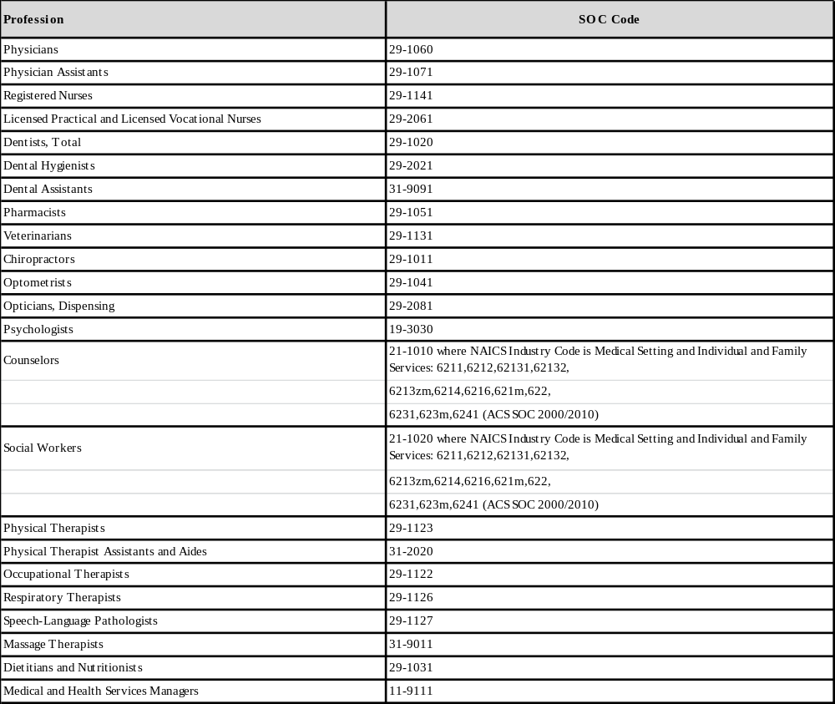

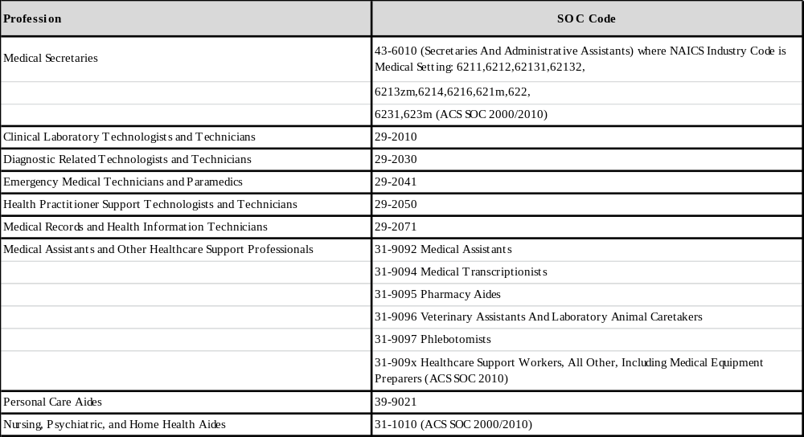

Bureau of Labor Statistics (BLS)

The Bureau of Labor Statistics provides many estimates and projections of wages and employment as well as detailed information about different professions. Health occupations data included on the AHRF are from the BLS May 2014 Occupational Employment Statistics (OES) file.

The OES collects wage and employment data from all US employers on a three-year cycle (on a rotating panel of roughly 200,000 each six months). The OES does not collect data from self-employed.

BLS total physicians data are calculated as the sum of the reported physicians by specialty data (SOC 29-1061 through 29-1069). For any state having one or more specialties not reported, the BLS total physicians data is suppressed.

As a final note, BLS has computed the relative standard error (RSE) of the employment estimates, and has provided the percent RSE for each employment value. If the PSRE of any employment estimate exceeds 30.0 percent, the value has been suppressed.

The following occupations are included on the AHRF as reported by BLS. The associated SOC codes and the CIP codes included for associated training data are also included in the table.

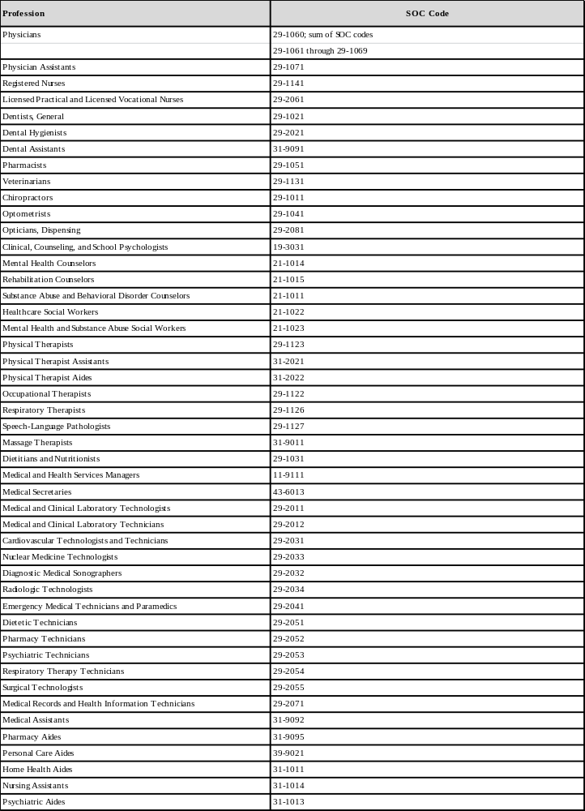

Integrated Postsecondary Education Data System (IPEDS)

Data from the Integrated Postsecondary Education Data System (IPEDS) on individuals completing educational programs in the 2012-2013 year were used. IPEDS is maintained by the National Center for Education Statistics, U.S. Department of Education (http://nces.ed.gov/ipeds/). IPEDS collects information from colleges, universities, and technical and vocational institutions that participate in federal student financial aid programs.

Each educational institution reports the number of students completing each curriculum program. Information includes number of males and females and number by race/ethnicity. The award level of the program is also noted. The information for 2013 in IPEDS was reported to discern the diversity of recent graduates. The type of program is coded according to Classification of Instructional Program (CIP) coding scheme. CIP codes were matched to SOC numbers to select the instructional programs analyzed for each health profession. The list of CIP codes associated with each health profession for which IPEDS data are reported is provided below.

Total completed degrees are reported as well as by sex and race/ethnicity. Specified degrees denotes those degrees awarded at the IPEDS degree award level considered relevant for a particular profession as noted below.

For most professions, IPEDS data are reported at the associate degree or above level. However, for certain professions, a certification program involving coursework of less than 1 year or more than 1 but less than 2 years is a major point of entry into these professions. The demographics of graduates in these certification programs are reported as these award levels pertain to particular professions.

The professions included on the AHRF and the associated SOC codes and CIP codes are identified in the table below.

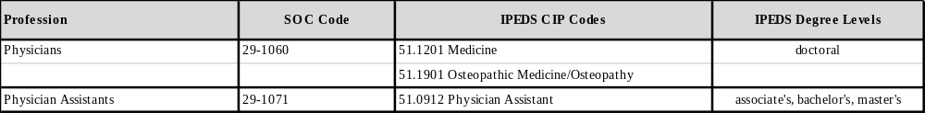

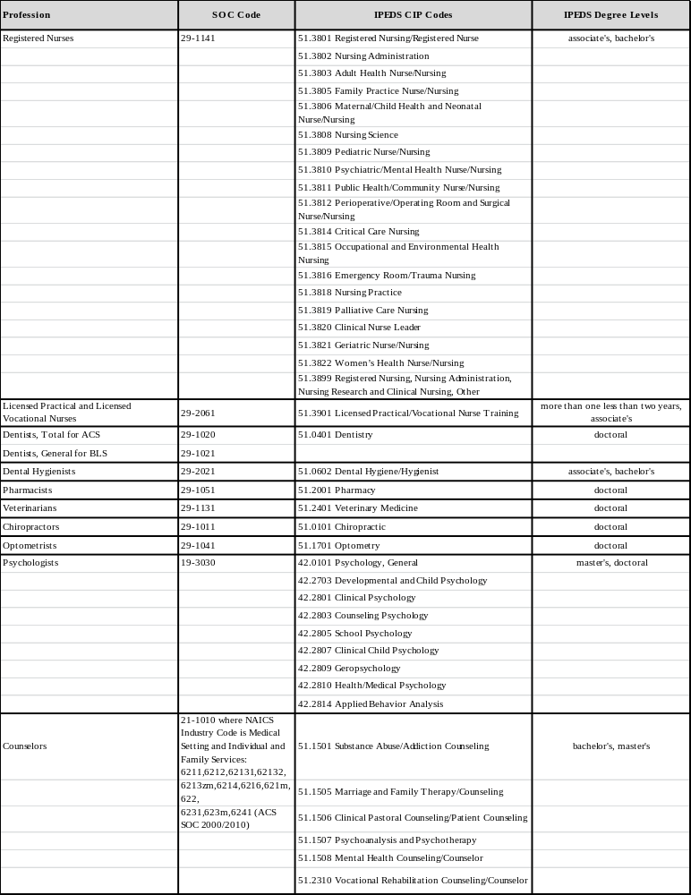

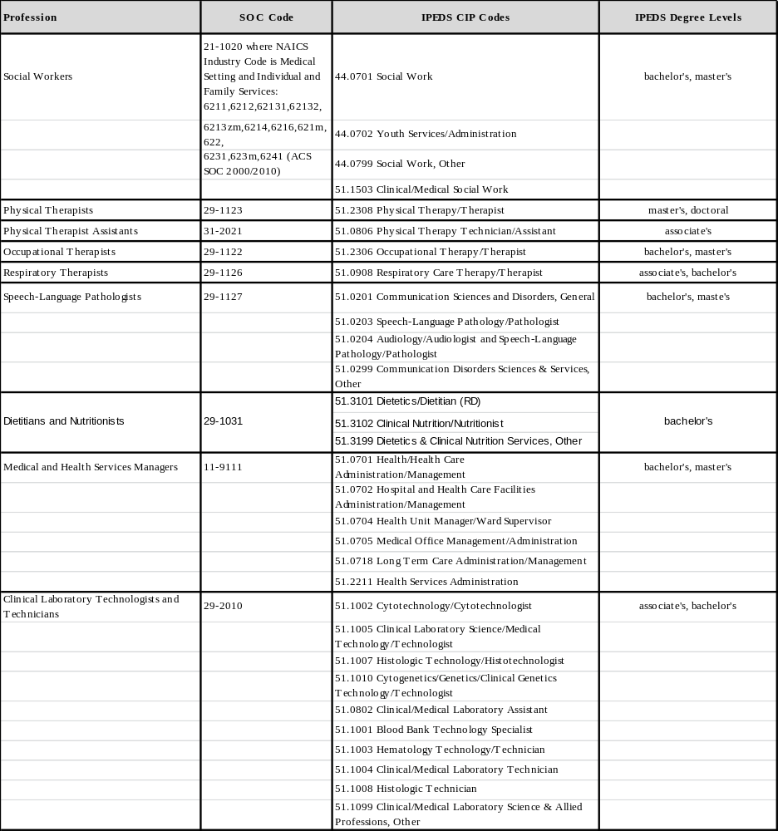

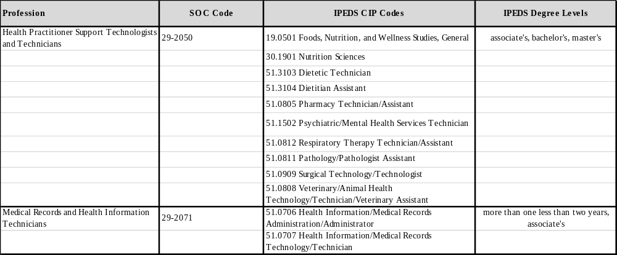

U.S. Census Bureau at http://www2.census.gov/acs2013_3yr/pums/ . See U.S. Census Bureau. A Compass for Understanding and Using American Community Survey Data: What PUMS Data Users Need to Know. Washington, DC: U.S. Government Printing Office; February 2009 (http://www.census.gov/acs/www/guidance_for_data_users/handbooks/).
Bureau of Labor Statistics, U.S. Department of Labor, Occupational Employment Statistics, [2014] [www.bls.gov/oes/]
This category scheme for analysis of race/ethnicity is commonly used to capture Hispanic as an ethnicity apart from race among Non-Hispanics.
http://www.bls.gov/oes

